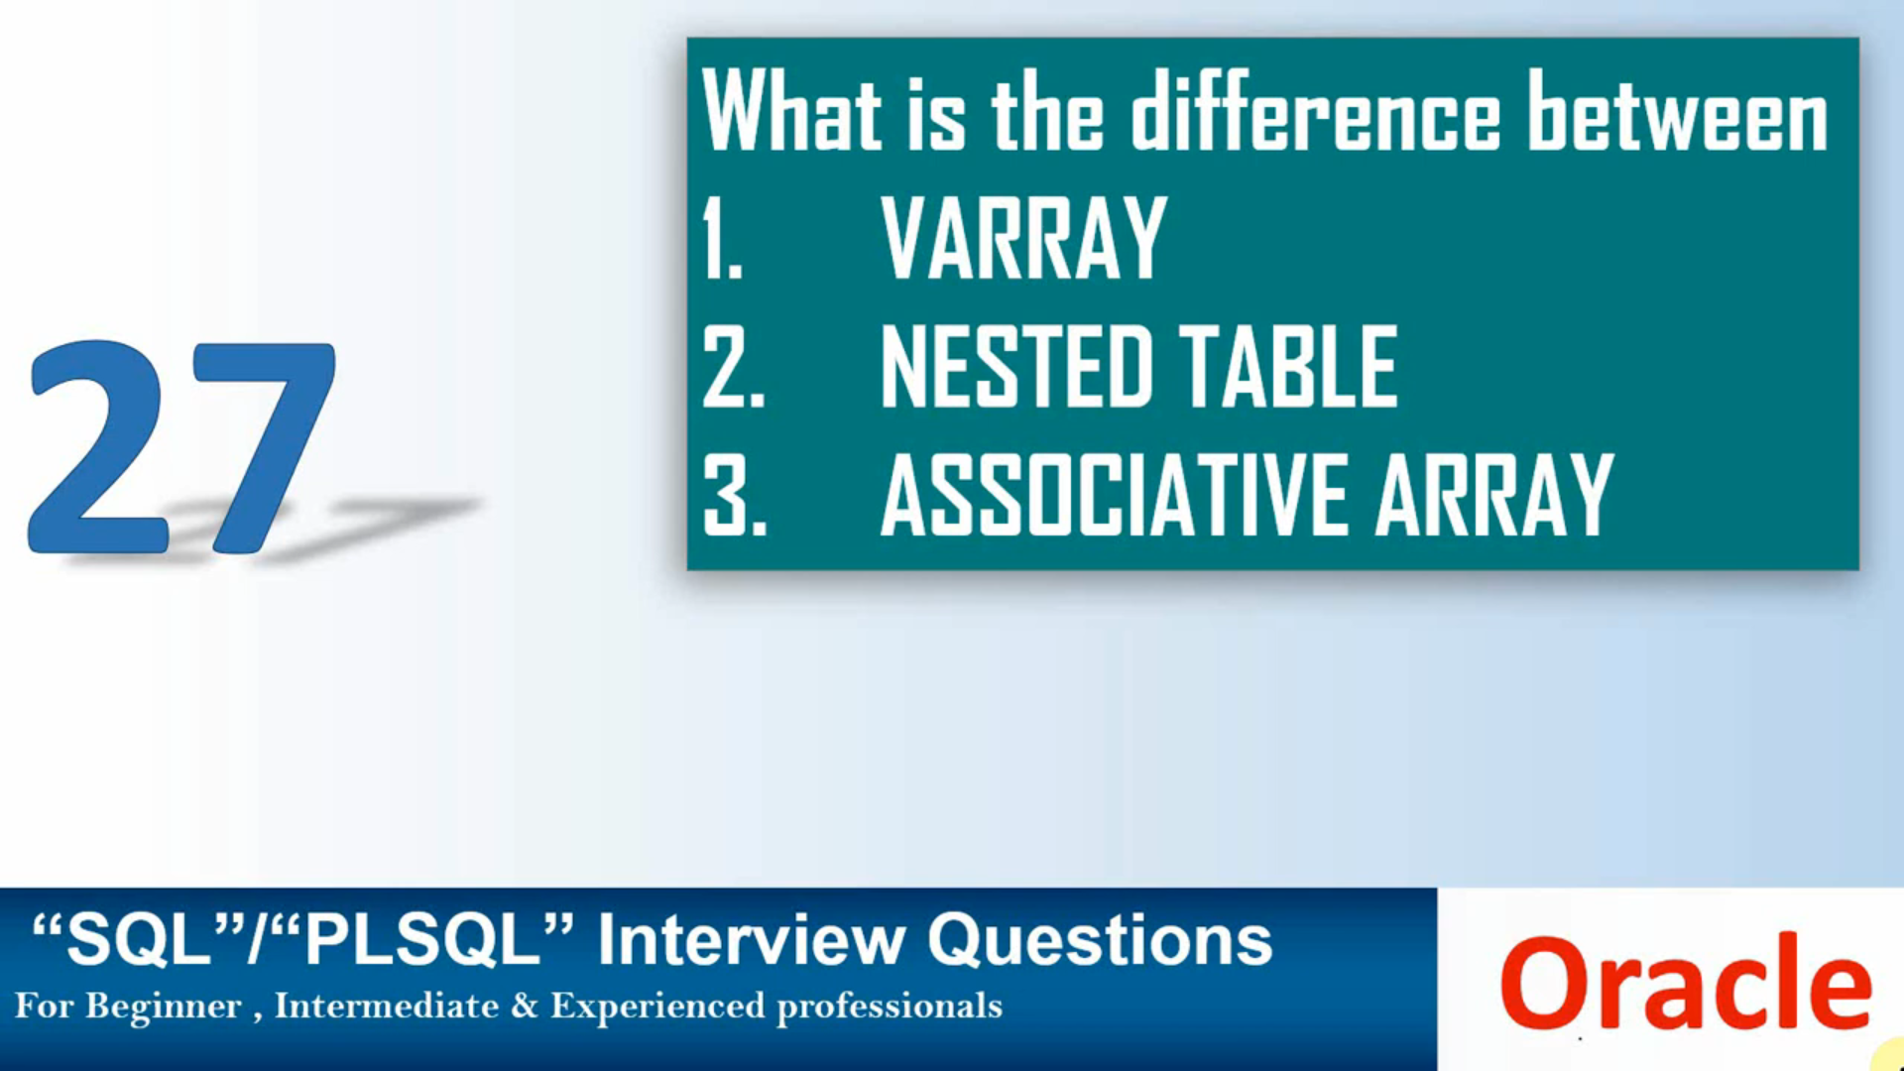 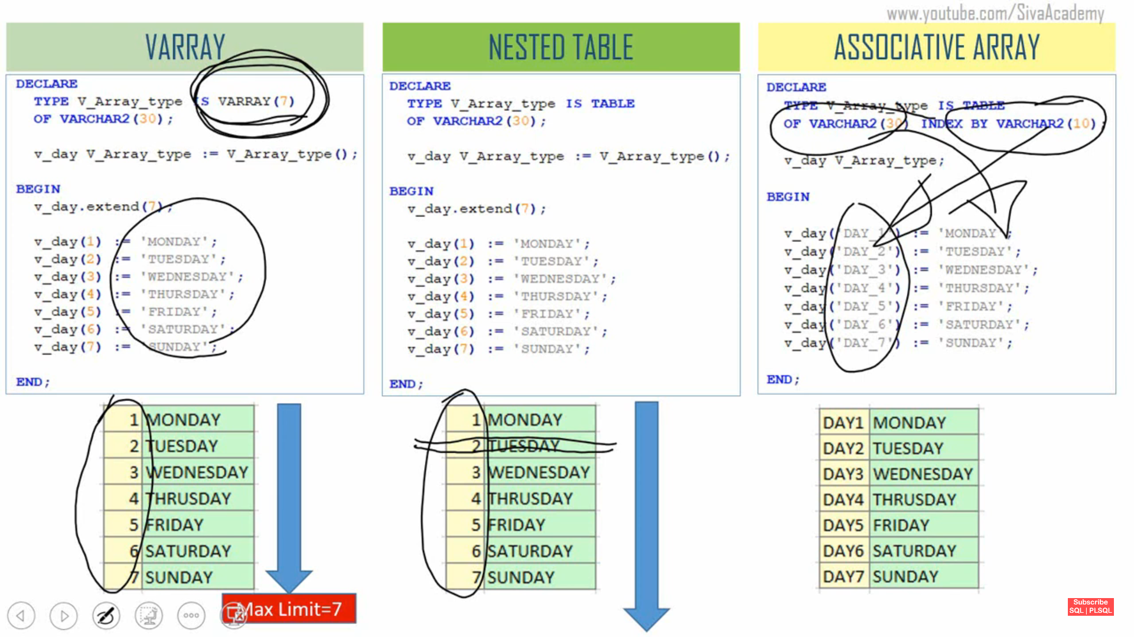

**Number of Elements** in array is fixed in Varray and unlimited for Nested Table and Associative Array

**Subscript Type(Index type)**->Varray and Nested Table predefined manitained oracle and index type was always integer whereas Associative array index type either number or varchar and value part also number or varchar because it was usedefined collection.

**Contienous or Sparse**-> Varray and Nested Table contienous collectons only will not able to delete the element in between Varray.In case Nested Table start with contienous collectons but it will delete in between.In Associative array it was usedeefined.

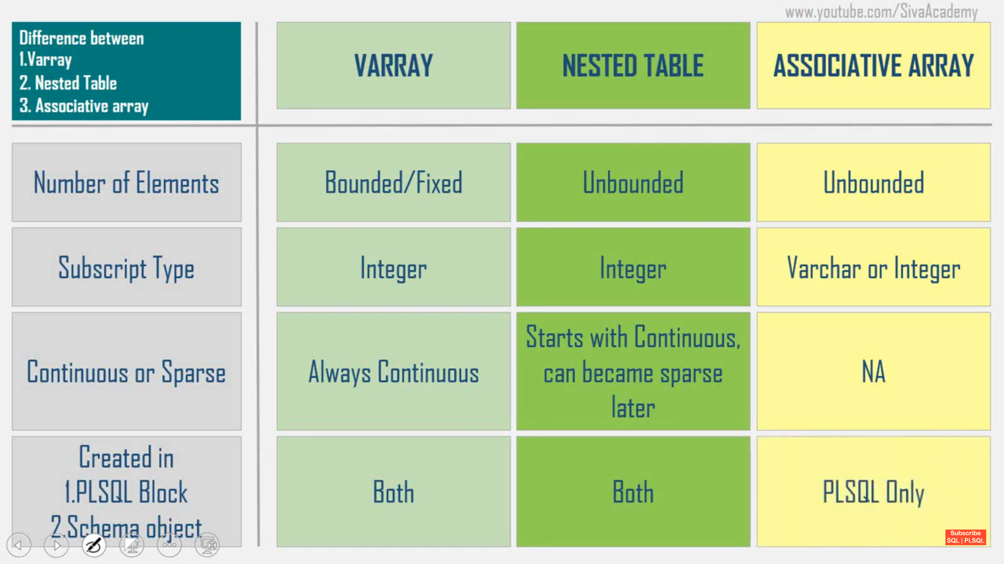

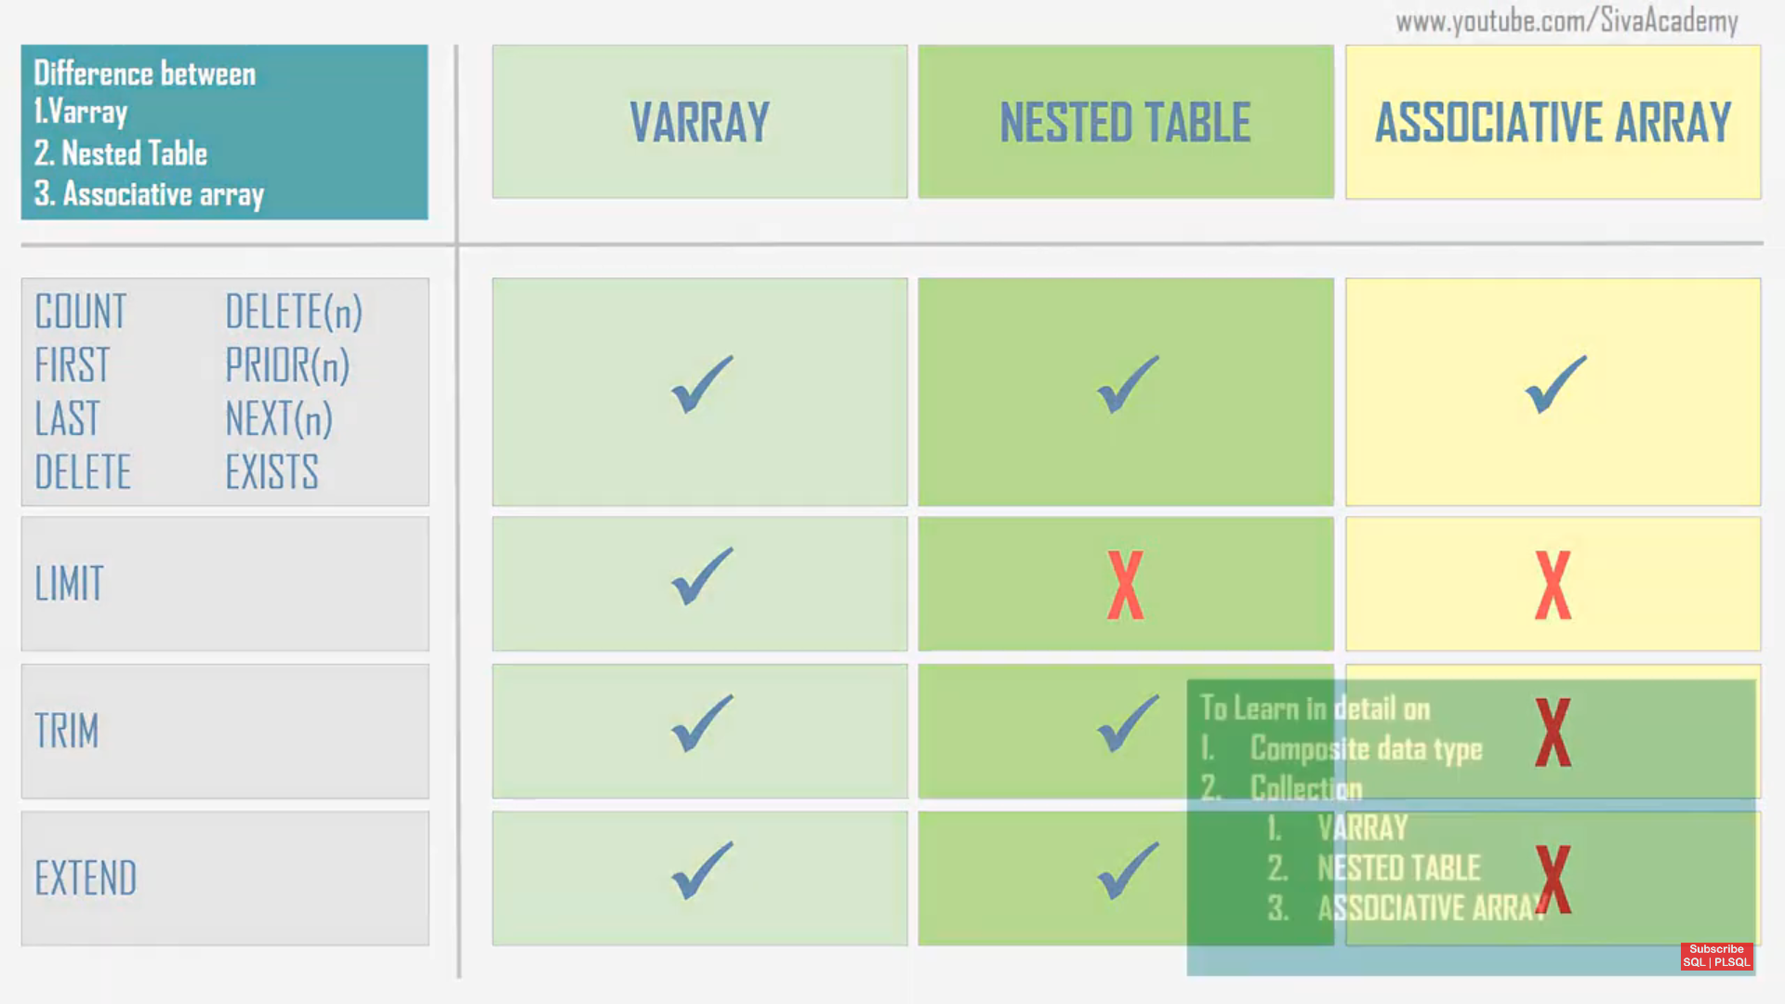

**ACID Properties-Atomicity, Consistency, Isolation, Durability**

1. **Atomicity: This ensures that all operations within a transaction are completed successfully. If any part of the transaction fails, the entire transaction is rolled back, leaving the database unchanged**
2. **Consistency: This guarantees that a transaction will bring the database from one valid state to another, maintaining database rules and constraints**
3. **Isolation: This property ensures that transactions are executed in isolation from one another. Intermediate states of a transaction are invisible to other transactions, preventing concurrent transactions from interfering with each other**
4. **Durability: Once a transaction has been committed, it remains so, even in the event of a system failure. This means that the changes made by the transaction are permanently recorded in the database**

**Reg_Expr :-**

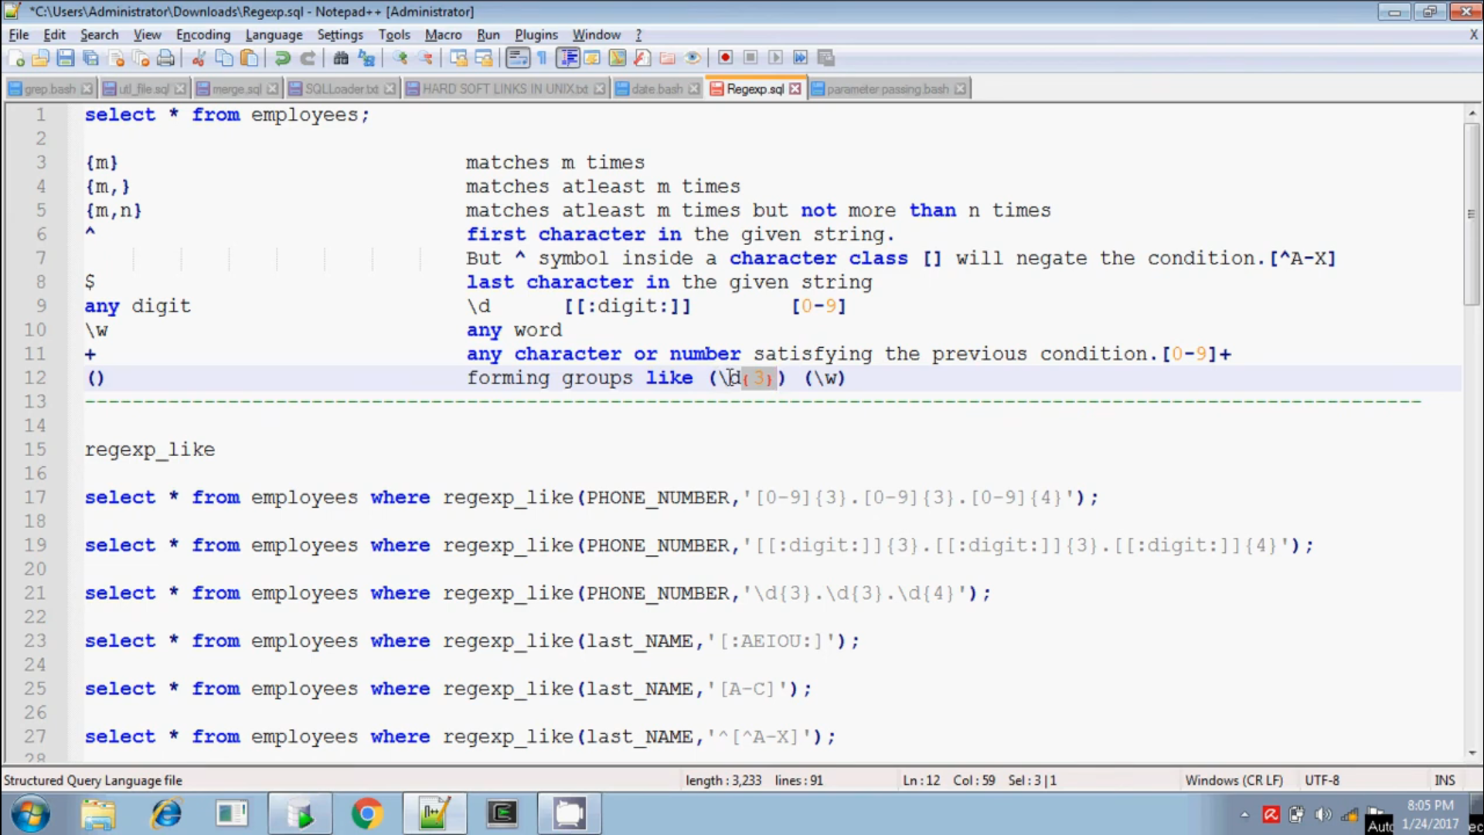

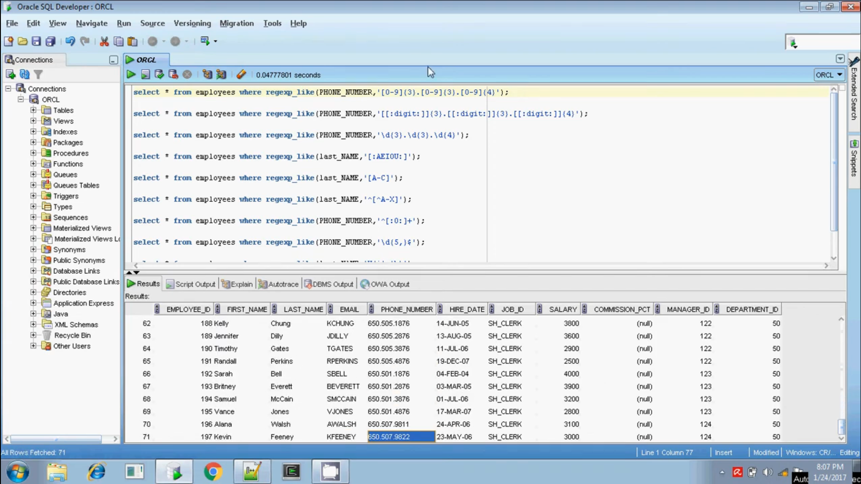

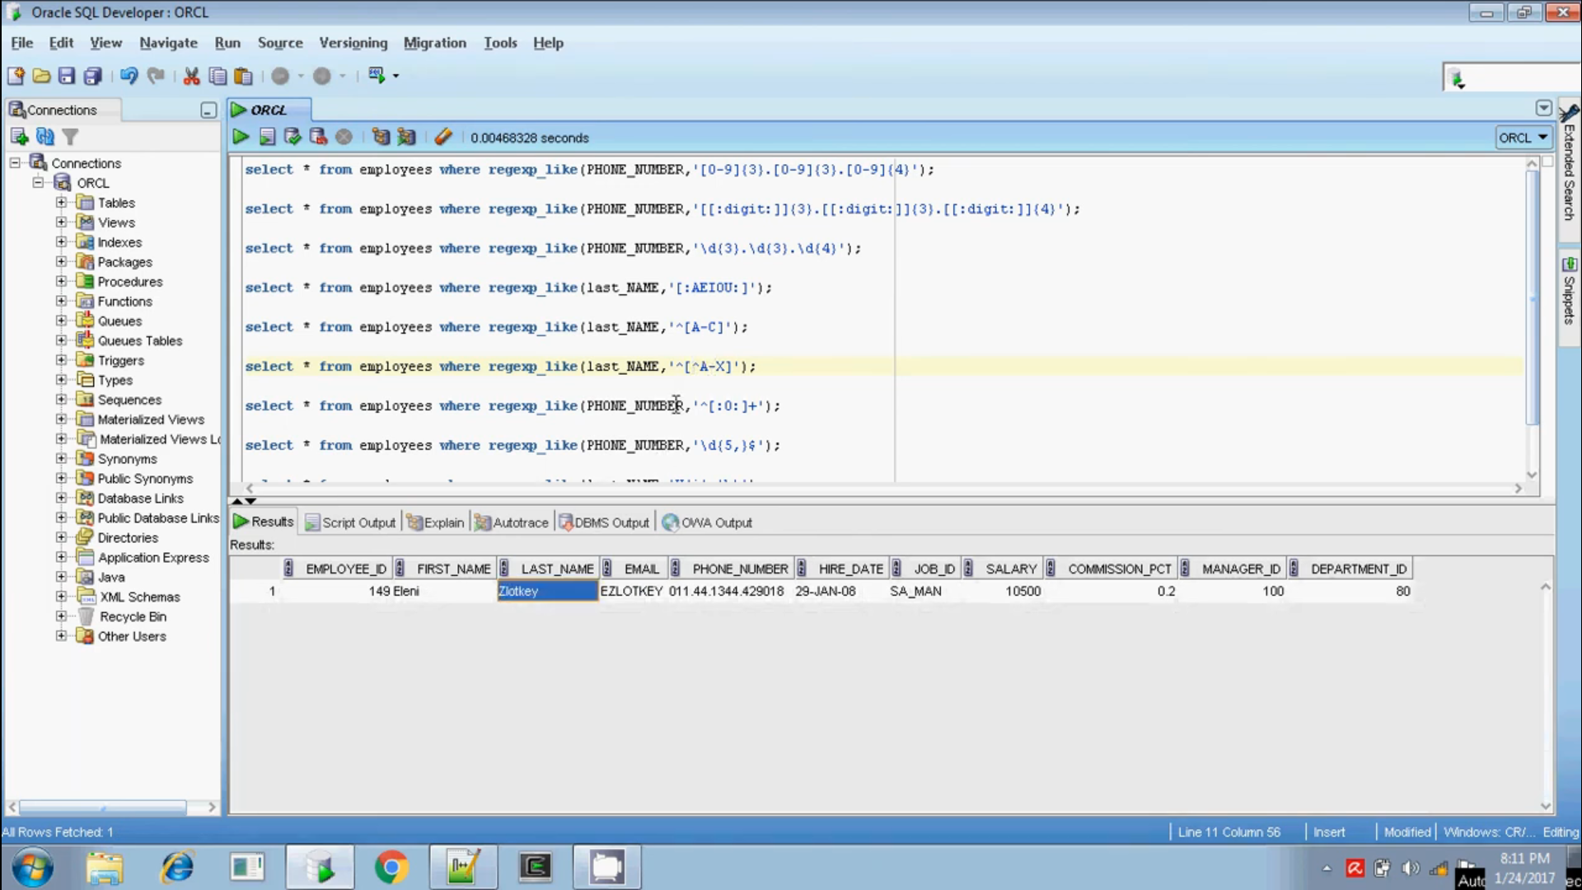

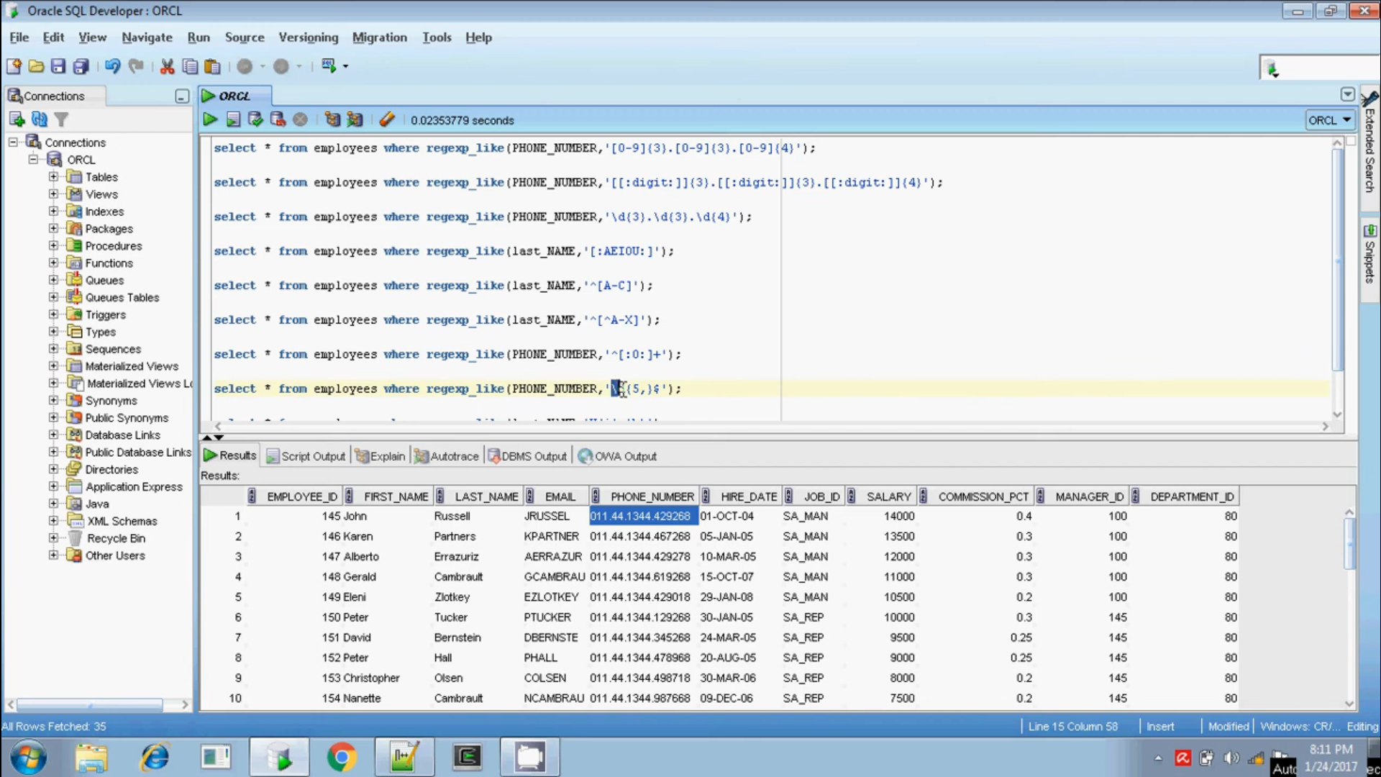

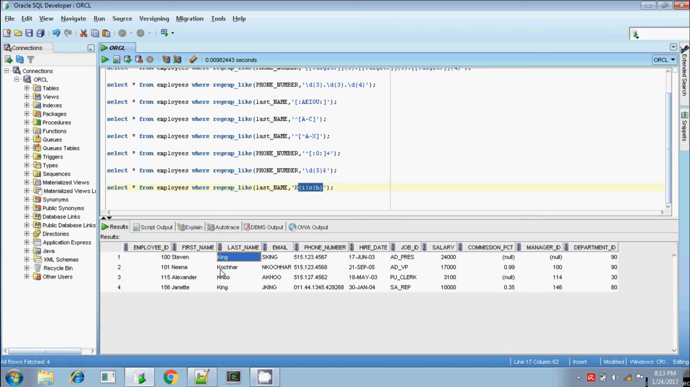

**Regular Expression(Reg_Exp) :-**

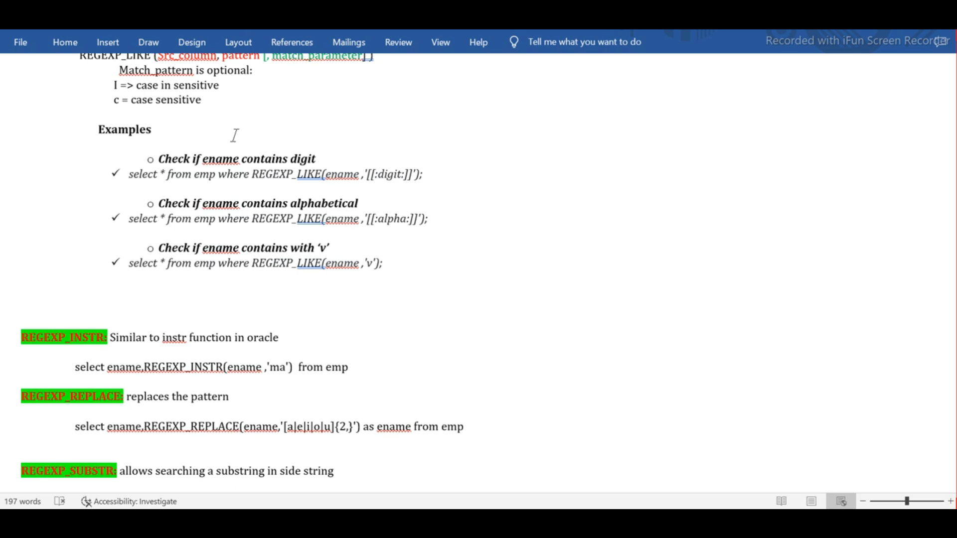

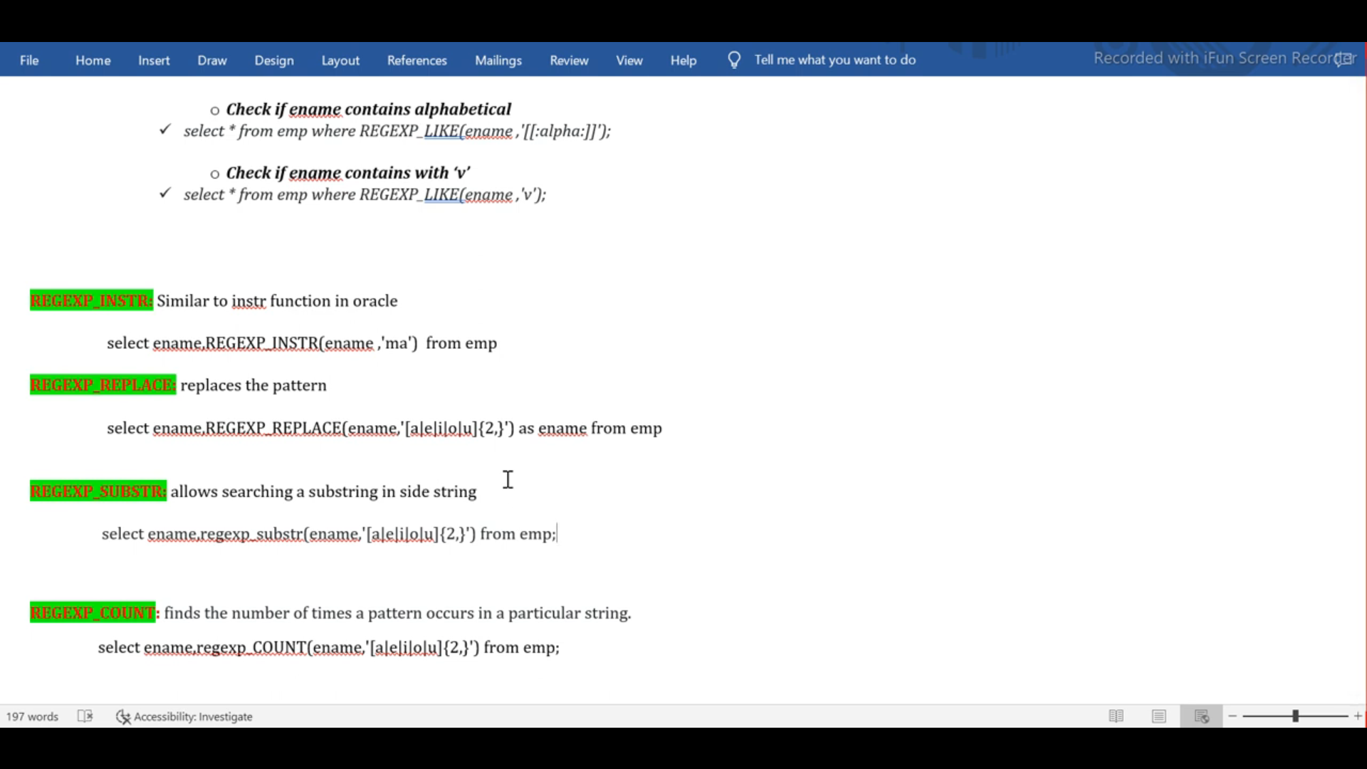

**Interview Questions :-**

**Write a PLSQL procedure retrieve all data in emp table using out parameter ?**

CREATE OR REPLACE PROCEDURE Getempdata (p_recordset OUT sys_refcursor) IS

BEGIN

OPEN p_recordset FOR SELECT * FROM emp;

END;

(Or)

DECLARE

p_recordset SYS_REFCURSOR;

v_emp_record emp%ROWTYPE;

BEGIN

OPEN p_recordset FOR SELECT * FROM emp;

LOOP

FETCH p_recordset INTO v_emp_record;

EXIT WHEN p_recordset%NOTFOUND;

DBMS_OUTPUT.PUT_LINE('Emp ID: ' || v_emp_record.empno || ', Name: ' || v_emp_record.ename || ', Job: ' || v_emp_record.job);

END LOOP;

CLOSE p_recordset;

END;

**2)How to copy collection into other collection with same structure**

DECLARE

TYPE emp_table_type IS TABLE OF emp%ROWTYPE;

emp_table1 emp_table_type;

emp_table2 emp_table_type;

BEGIN

SELECT * BULK COLLECT INTO emp_table1 FROM emp;

emp_table2 := emp_table1;

FOR i IN emp_table2.FIRST .. emp_table2.LAST LOOP

DBMS_OUTPUT.PUT_LINE('Emp ID: ' || emp_table2(i).empno || ', Name: ' || emp_table2(i).ename);

END LOOP;

END;

3)**I have collection, we stored data in collection now I want to delete only the data in the table that matches the data in your collection ?**

DECLARE

TYPE emp_table_type IS TABLE OF emp%ROWTYPE;

emp_table emp_table_type;

BEGIN

SELECT * BULK COLLECT INTO emp_table FROM emp;

FORALL i IN emp_table.FIRST .. emp_table.LAST

DELETE FROM emp WHERE empno = emp_table(i).empno;

COMMIT;

END;

(Or)

declare  
type t1 is table of emp%rowtype;  
tab1 t1;  
begin  
  select * bulk collect into tab1 from emp;  
for i in 1..tab1.count loop  
    dbms_output.put_line('Before details '||i||' - '||tab1(i).ename);  
  end loop;   
     tab1.delete(6);     
    dbms_output.put_line('no');  
  for i in 1..tab1.count loop  
     If tab1.exists(i)  Then  
    dbms_output.put_line(' After details '||i||' - '||tab1(i).ename);  
   end if;  
  end loop;  
end;

**4)Need to insert 1 million records into a table and log any errors that occur, you can use PL/SQL with exception handling**

CREATE TABLE error_log (

error_id NUMBER GENERATED BY DEFAULT AS IDENTITY,

error_message VARCHAR2(4000),

error_time TIMESTAMP DEFAULT CURRENT_TIMESTAMP

);

DECLARE

TYPE emp_table_type IS TABLE OF emp%ROWTYPE;

emp_table emp_table_type;

l_error_message VARCHAR2(4000);

BEGIN

-- Populate emp_table with data from emp

SELECT * BULK COLLECT INTO emp_table FROM emp;

-- Insert records into the emp_backup table

FORALL i IN emp_table.FIRST .. emp_table.LAST SAVE EXCEPTIONS

INSERT INTO emp_backup VALUES emp_table(i);

EXCEPTION

WHEN OTHERS THEN

FOR i IN 1 .. SQL%BULK_EXCEPTIONS.COUNT LOOP

l_error_message := 'Error: ' || SQLERRM(SQL%BULK_EXCEPTIONS(i).ERROR_CODE) ||

' at index ' || SQL%BULK_EXCEPTIONS(i).ERROR_INDEX;

INSERT INTO error_log (error_message) VALUES (l_error_message);

END LOOP;

COMMIT;

END;

**5)The query was running till yesterday is fine but today it was very slow and also statistics also up to date what we need to check ?**

1. **Query Execution Plan**: Check if the execution plan has changed. Sometimes, the database optimizer might choose a different plan due to changes in data distribution or other factors. You can use tools like EXPLAIN PLAN in Oracle or SHOW PLAN in SQL Server to compare the current execution plan with the previous one.
2. **Index Usage**: Ensure that the indexes are being used efficiently. Sometimes, indexes might become fragmented or might not be used as expected. Rebuilding or reorganizing indexes can help.
3. **Locks and Contention**: Check for any locks or contention issues that might be causing delays. You can use views like V$LOCK in Oracle or sys.dm_tran_locks in SQL Server to identify any blocking sessions
4. **Resource Bottlenecks**: Monitor the system resources such as CPU, memory, and disk I/O. High resource utilization can slow down query performance. Tools like top or vmstat on Unix/Linux systems, or Performance Monitor on Windows, can help identify resource bottlenecks.
5. **Concurrency Issues**: High levels of concurrent access can lead to contention and slow down queries. Check if there has been an increase in the number of users or processes accessing the database simultaneously.
6. **Database Configuration**: Review the database configuration parameters. Sometimes, changes in configuration settings can impact performance. Ensure that parameters like memory allocation, cache sizes, and parallelism settings are optimized.
7. **Network Latency**: If your database is accessed over a network, check for any network latency issues that might be affecting performance.
8. **Query Optimization**: Review the query itself for any potential optimizations. Sometimes, rewriting the query or breaking it into smaller parts can improve performance.

**How to delete duplicate records in table ?**

DELETE FROM emp

WHERE ROWID NOT IN (

SELECT MIN(ROWID)

FROM emp

GROUP BY empno, ename, job, mgr, hiredate, sal, comm, deptno);

**(Or)**

WITH CTE AS (SELECT *,

ROW_NUMBER() OVER (PARTITION BY empno, ename,sal ORDER BY empno) AS rn FROM emp)

DELETE FROM emp WHERE empno IN (SELECT empno FROM CTE WHERE rn > 1**);**

**Difference Between Execution Plan and Explain Plan :-**

**Explain Plan**

* What it is: A prediction of how the database will execute your query.
* When to use it: Before running your query, to see what the database plans to do.
* Example: Think of it like a map showing the route you plan to take on a trip.
* **EXPLAIN PLAN FOR**
* **SELECT * FROM emp WHERE deptno = 10;**
* **SELECT * FROM TABLE(DBMS_XPLAN.DISPLAY);**

**Execution Plan**

* What it is: The actual steps the database took to execute your query.
* When to use it: After running your query, to see what really happened.
* Example: Think of it like a GPS log showing the route you actually took on your trip.

**Syntax**

* Run your query:
* **SELECT * FROM emp WHERE deptno = 10;**
* View the actual execution plan:

**SELECT * FROM TABLE(DBMS_XPLAN.DISPLAY_CURSOR(NULL, NULL, 'ALLSTATS LAST'));**

Key Differences

* Prediction vs. Reality: Explain Plan is the predicted route, while the Execution Plan is the actual route taken.
* Timing: Explain Plan is used before running the query, and Execution Plan is analysed after running the query.
* Accuracy: The Execution Plan is more accurate because it shows what really happened**.**

**Merge Statement :-**

MERGE INTO emp e

USING emp_updates u

ON (e.empno = u.empno)

WHEN MATCHED THEN

UPDATE SET e.ename = u.ename,

e.hiredate = u.hiredate,

e.sal = u.sal

WHEN NOT MATCHED THEN

INSERT (empno, ename, hiredate, sal)

VALUES (u.empno, u.ename, u.hiredate, u.sal)

WHEN NOT MATCHED BY SOURCE THEN

DELETE;

**ORA-30926: unable to get a stable set of rows in the source tables**

**How to check where an error occurred in an Oracle PL/SQL procedure :-**

To find the exact line number where an error occurred in an Oracle PL/SQL procedure, you can use the **DBMS_UTILITY.FORMAT_ERROR_BACKTRACE** function. This function provides a formatted string that includes the line number where the error was raised.

CREATE OR REPLACE PROCEDURE add_numbers (

num1 IN NUMBER,

num2 IN NUMBER,

result OUT NUMBER

) AS

BEGIN

result := num1 + num2;

EXCEPTION

WHEN OTHERS THEN

DBMS_OUTPUT.PUT_LINE('Error: ' || SQLERRM);

DBMS_OUTPUT.PUT_LINE('Backtrace: ' || DBMS_UTILITY.FORMAT_ERROR_BACKTRACE);

RAISE;

END;

**Instead Of Trigger**

CREATE OR REPLACE TRIGGER emp_dept_view_ins_upd

INSTEAD OF INSERT OR UPDATE ON emp_dept_view

FOR EACH ROW

BEGIN

IF INSERTING THEN

INSERT INTO employees (emp_id, emp_name, dept_id)

VALUES (:NEW.emp_id, :NEW.emp_name, (SELECT dept_id FROM departments WHERE dept_name = :NEW.dept_name));

ELSIF UPDATING THEN

UPDATE employees

SET emp_name = :NEW.emp_name,

dept_id = (SELECT dept_id FROM departments WHERE dept_name = :NEW.dept_name)

WHERE emp_id = :OLD.emp_id;

END IF;

END;

**Reverse Key Index :-**

A **Reverse key index** in Oracle is a type of index that reverses the bytes of the key value before storing it in the index. This technique is primarily used to reduce contention on the right-most leaf blocks of the index.

CREATE INDEX t1_id_idx ON t1 (id) REVERSE;

**Real Time Project Example**

Create or Replace Procedure PR_ISOM_CRDTL_FILE(p_start_dt date,p_end_dt date) as

V_REPORT_NAME VARCHAR2(50);

V_RECORD_CNT NUMBER :=0;

F_UTL_FILE UTL_FILE.FILE_TYPE;

V_COLUMN_HEADER VARCHAR2(1000);

V_DETAIL_RECORD VARCHAR2(4000);

V_TRAILER_RECORD VARCHAR2(1000);

v_slacr_number tbl_invoice.slacr_num%type;

v_clam_id varchar2(100);

v_violation_id varchar2(100);

v_ubi_id varchar2(100);

v_agency_task_order_num varchar2(100);

total_line_item_amount varchar2(100);

v_invoice_num varchar2(100);

v_bill_date varchar2(100);

cursor c1 is

select slacr_number,clam_id,violation_id,ubi_id,agency_task_order_num,total_line_item_amount,invoice_num,to_char(billdate,'YYYY-MM-DD')billdate FROM TBL_INVOICE WHERE CONTR_INV_DATE between P_START_DT and p_END_DT;

BEGIN

V_FILE_SEQ_NUM := S_FILE_SEQ_NUM.NEXTVAL;

SELECT 'EIS_ISOM_CRINVOICE' || '_' || TO_CHAR(SYSDATE, 'YYYYMMDD') || '_' || TO_CHAR(SYSDATE, 'HH24MISS') || '.csv'

INTO V_REPORT_NAME FROM DUAL;

F_UTL_FILE := UTL_FILE.FOPEN('EISOUT', V_REPORT_NAME, 'w');

SELECT 'HDR'||'|'|| 'EIS' ||'|'|| TO_CHAR(SYSDATE, 'YYYY-MM-DD')||'|'||TRIM(TO_CHAR(V_FILE_SEQ_NUM,'00000000'))

INTO V_COLUMN_HEADER FROM DUAL;

UTL_FILE.PUT_LINE(F_UTL_FILE,V_COLUMN_HEADER);

FOR V_REC1 IN C1

LOOP

BEGIN

V_RECORD_CNT := V_RECORD_CNT + 1;

V_SLACR_NUMBER := V_REC1.SLACR_NUMBER;

V_CLAIM_ID := V_REC1.CLAIM_ID;

V_VIOLATION_ID := V_REC1.VIOLATION_ID;

V_BILL_DATE := V_REC1.BILL_DATE;

V_TOTAL_LINE_ITEM_AMOUNT := V_REC1.TOTAL_LINE_ITEM_AMOUNT;

V_UBI_ID := V_REC1.UBI_ID;

V_Invoice_num := V_REC1.Invoice_num;

V_AGNCY_TASK_ORDER_NUM := V_REC1.AGNCY_TASK_ORDER_NUM;

V_DETAIL_RECORD:= V_SLACR_NUMBER || '|' || V_CLAIM_ID || '|' || V_VIOLATION_ID || '|' || V_BILL_DATE || '|' || V_TOTAL_LINE_ITEM_AMOUNT || '|' ||

V_UBI_ID || '|' || V_Invoice_num || '|' || V_AGNCY_TASK_ORDER_NUM;

UTL_FILE.PUT_LINE(F_UTL_FILE,V_DETAIL_RECORD);

END;

END LOOP;

V_TRAILER_RECORD := 'TRL' || '|' || V_RECORD_CNT;

UTL_FILE.PUT_LINE(F_UTL_FILE,V_TRAILER_RECORD);

UTL_FILE.FCLOSE(F_UTL_FILE);

begin

INSERT INTO T_OUTBOUND_QUE (ROW_ID,

FILE_LOCATION,

FILE_NAME,

PROCESS_STATUS,

REQUEST_DATE,

RETRY_CNT,

SENDER_TO_NOTIFY,

SENDER_NOTIFY_METHOD,

TRANSFER_DEST,

TRANSFER_METHOD)

VALUES (S_OUTBOUND_QUE.NEXTVAL,

'/eis/fxfer/out',

V_REPORT_NAME,

'PENDING',

SYSDATE,

0,

'DL-EIS_NS2020_Prod_Support_Team@att.com',

'SMTP',

2674,--Can use 4799 in Test DB

'DMAAP');

exception

when others then

RAISE_APPLICATION_ERROR (-20008,'Error occurred while inserting file into outbound que'||SUBSTR(SQLERRM, 1, 200 ));

end;

exception

when others then

RAISE_APPLICATION_ERROR (-20008,'Error occurred while generating SLACRDTL file'||SUBSTR(SQLERRM, 1, 200 ));

END;

**Write the query in Oracle SQL to find employees who joined in the last month ?**

SELECT *

FROM employees WHERE join_date >= ADD_MONTHS(SYSDATE, -1);

**How to know currently which query running for the particular user?**

SELECT s.sid,s.username,s.status,s.sql_id,

s.sql_exec_start, q.sql_text

FROM v$session s JOIN v$sqlarea q

ON s.sql_address = q.address

WHERE s.username = 'YOUR_USERNAME'

AND s.status = 'ACTIVE';

**How to influence optimizer to use particular explain plan in oracle ?**

To influence the Oracle SQL optimizer to use a specific execution plan, you can use several techniques. Here are some of the most effective methods:

1. **Optimizer Hints**: Hints are comments in your SQL statement that instruct the optimizer on how to execute the query. For example, you can use hints to specify the use of a particular index or join method**.**
2. SELECT /*+ INDEX(employees emp_join_date_idx) */ *
3. FROM employees
4. WHERE join_date >= ADD_MONTHS(SYSDATE, -1);
5. **SQL Plan Baselines**: SQL Plan Baselines allow you to capture and use a specific execution plan for a SQL statement. This ensures that the optimizer uses the same plan unless a better one is found.
6. BEGIN
7. DBMS_SPM.LOAD_PLANS_FROM_CURSOR_CACHE(
8. sql_id => 'your_sql_id'
9. );
10. END;
11. **SQL Profiles**: SQL Profiles provide additional statistics to the optimizer, helping it generate better execution plans. They are created using the SQL Tuning Advisor.
12. BEGIN
13. DBMS_SQLTUNE.ACCEPT_SQL_PROFILE(
14. task_name => 'your_task_name',
15. name => 'your_profile_name'
16. );
17. END;
18. **Stored Outlines**: Although considered a legacy feature, stored outlines can still be used to force the optimizer to use a specific execution plan.
19. CREATE OUTLINE outline_name
20. FOR CATEGORY category_name
21. ON
22. SELECT * FROM employees WHERE join_date >= ADD_MONTHS(SYSDATE, -1);
23. **Initialization Parameters**: Certain initialization parameters can influence the optimizer's behavior at the instance or session level. For example, setting the OPTIMIZER_MODE parameter to FIRST_ROWS or ALL_ROWS can affect the optimizer's decisions.

ALTER SESSION SET OPTIMIZER_MODE = FIRST_ROWS;

**what is the difference between sql profiler and dbms_profiler**

The main difference between SQL Profiler and DBMS_Profiler lies in their purposes and the types of performance analysis they provide:

1. **SQL Profiler**:
   * **Purpose**: SQL Profiler is primarily used to monitor and analyze SQL Server events. It captures and logs detailed information about SQL Server activities, such as SQL queries, stored procedures, and other database operations.
   * **Usage**: It is used to diagnose performance issues, audit database activity, and troubleshoot problems in SQL Server environments.
   * **Scope**: SQL Profiler focuses on SQL Server and provides insights into the execution of SQL queries, including execution plans, resource usage, and query performance.
2. **DBMS_Profiler**:
   * **Purpose**: DBMS_Profiler is an Oracle package used to profile the run-time behavior of PL/SQL code. It helps identify performance bottlenecks within PL/SQL functions, procedures, and packages.
   * **Usage**: It is used to analyze the execution counts, time spent on each line of code, and to pinpoint inefficiencies in PL/SQL code.
   * **Scope**: DBMS_Profiler is specific to Oracle databases and focuses on PL/SQL code performance rather than SQL queries alone

In summary, SQL Profiler is used for monitoring and analyzing SQL Server activities, while DBMS_Profiler is used for profiling and optimizing PL/SQL code in Oracle databases. Each tool serves a distinct purpose and is tailored to different types of performance analysis.

**AWR Report Example :-**

An Automatic Workload Repository (AWR) report in Oracle provides a comprehensive overview of database performance over a specified period. Here's a simplified example of what an AWR report might include:

**Example AWR Report Sections**

1. **Report Summary**:
   * **DB Name**: ExampleDB
   * **Instance**: example1
   * **Snapshot Period**: From 01-Feb-2025 10:00 to 01-Feb-2025 11:00
   * **Elapsed Time**: 60 minutes
   * **DB Time**: 120 minutes
2. **Load Profile**:
   * **DB CPU**: 50%
   * **Logical Reads**: 100,000 per second
   * **Physical Reads**: 500 per second
   * **Redo Size**: 1 GB per hour
3. **Top 5 Timed Foreground Events**:

| **Event** | **Waits** | **Time (s)** | **Avg Wait (ms)** | **% DB Time** |
| --- | --- | --- | --- | --- |
| db file sequential read | 10,000 | 5,000 | 0.5 | 50% |
| log file sync | 2,000 | 2,000 | 1.0 | 20% |
| CPU time | N/A | 1,500 | N/A | 15% |
| db file scattered read | 5,000 | 1,000 | 0.2 | 10% |
| direct path read temp | 1,000 | 500 | 0.5 | 5% |

1. **Instance Efficiency Percentages**:
   * **Buffer Cache Hit Ratio**: 99%
   * **Library Cache Hit Ratio**: 98%
   * **Redo NoWait Ratio**: 99%
2. **SQL Statistics**:
   * **Top SQL by Elapsed Time**:
   * SELECT * FROM employees WHERE join_date >= ADD_MONTHS(SYSDATE, -1);
     + **Elapsed Time**: 300 seconds
     + **Executions**: 100
     + **Elapsed Time per Exec**: 3 seconds

**Key Areas to Focus On**

* **Load Profile**: Provides an overview of the workload on the database.
* **Top Timed Events**: Highlights the events that are consuming the most time.
* **Instance Efficiency**: Shows how efficiently the database is performing.
* **SQL Statistics**: Identifies the most resource-intensive SQL statements.
* SELECT name, dob,
* TRUNC((SYSDATE - dob) / 365.25) AS age
* FROM emp;

SELECT name, dob,

FLOOR(MONTHS_BETWEEN(SYSDATE, dob) / 12) AS age

FROM emp;

**What are the different types of performance tuning methods in Oracle :-**

1. **SQL Tuning :**
   * **Query Optimization**: Rewrite SQL queries to improve performance.
   * **Indexing**: Create and maintain indexes to speed up data retrieval.
   * **Optimizer Hints**: Use hints to influence the optimizer's choice of execution plan.
2. **Instance Tuning:**
   * **Memory Management**: Adjust memory allocation for the System Global Area (SGA) and Program Global Area (PGA).
   * **Process Management**: Optimize the number of background processes and their configurations.
   * **Parameter Tuning**: Set and adjust initialization parameters to improve performance.
3. **Storage Tuning:**
   * **I/O Optimization**: Distribute data across multiple disks to balance I/O load.
   * **Tablespace Management**: Use appropriate tablespace configurations and storage parameters.
   * **Data Partitioning**: Partition large tables to improve query performance and manageability.
4. **Network Tuning:**
   * **Connection Management**: Optimize database connections and session management.
   * **Network Configuration**: Adjust network parameters to reduce latency and improve throughput.
5. **Application Tuning:**
   * **Code Optimization**: Optimize application code to reduce database load.
   * **Connection Pooling**: Use connection pooling to manage database connections efficiently.
   * **Batch Processing**: Implement batch processing for large data operations.
6. **System Tuning:**
   * **Operating System Tuning**: Optimize OS settings for better database performance.
   * **Hardware Upgrades**: Upgrade hardware components like CPU, memory, and storage.
7. **Automatic Workload Repository (AWR) and Active Session History (ASH):**
   * AWR Reports: Analyze AWR reports to identify performance bottlenecks.
   * ASH Reports: Use ASH reports to monitor active sessions and identify issues.
8. **Using Oracle Performance Tools:**
   * SQL Tuning Advisor: Provides recommendations for optimizing SQL queries.
   * SQL Access Advisor: Recommends indexes and materialized views to improve query performance.
   * DBMS_PROFILER: Profiles PL/SQL code to identify performance bottlenecks.

**What is Partition Exchange Method :-**

The Partition Exchange Method in Oracle allows you to exchange data between a partitioned table and a non-partitioned table (or another partitioned table) without physically moving the data. This method is useful for efficiently managing large datasets and performing maintenance tasks. Here's a simplified explanation of how it works:

**Steps for Partition Exchange :-**

Create a Non-Partitioned Table: First, create a non-partitioned table with the same structure as the partitioned table.

CREATE TABLE non_partitioned_table (

id NUMBER,

created_date DATE,

data VARCHAR2(50)

);

Create a Partitioned Table: Create a partitioned table with the desired partitioning scheme.

CREATE TABLE partitioned_table (

id NUMBER,

created_date DATE,

data VARCHAR2(50)

)

PARTITION BY RANGE (created_date) (

PARTITION p1 VALUES LESS THAN (TO_DATE('2025-01-01', 'YYYY-MM-DD')),

PARTITION p2 VALUES LESS THAN (TO_DATE('2026-01-01', 'YYYY-MM-DD'))

);

**Exchange Partition**: Use the EXCHANGE PARTITION command to swap the data between the non-partitioned table and a specific partition of the partitioned table.

ALTER TABLE partitioned_table

EXCHANGE PARTITION p1

WITH TABLE non_partitioned_table

WITHOUT VALIDATION;

**Benefits of Partition Exchange**

* Efficiency: The data is not physically moved, making the operation very fast.
* Flexibility: Allows for easy data management and maintenance, such as loading data into a non-partitioned table and then swapping it into a partitioned table.
* Minimal Downtime: Reduces downtime during data maintenance operations.

**Example Use Case**

Imagine you have a large table of sales data partitioned by month. You can load new sales data into a non-partitioned staging table and then use the partition exchange method to quickly swap the new data into the appropriate partition.

**Sub Partition Example :-**

CREATE TABLE sales (

sale_id NUMBER,

sale_date DATE,

amount NUMBER

) PARTITION BY RANGE (sale_date)

INTERVAL (NUMTOYMINTERVAL(1, 'MONTH'))

SUBPARTITION BY HASH (sale_id)

SUBPARTITIONS 4

(PARTITION p0 VALUES LESS THAN (TO_DATE('2025-01-01', 'YYYY-MM-DD')));

SELECT * FROM sales PARTITION (p1);

SELECT partition_name, high_value

FROM user_tab_partitions

WHERE table_name = 'YOUR_TABLE_NAME';

or

SELECT table_name

FROM user_part_tables

WHERE table_name = 'SALES';

**I have table Student**

**Sid Sname Sub Marks**

100 Ram Maths 60

100 Ram Physics 70

100 Ram Chemistry 90

101 Ravi Maths 90

101 Ravi Physics 50

101 Ravi Chemistry 75

**Write a query to get result pass or fail for one student all subject marks should be greater than equal to 60 then only Pass if any subject of student marks less than 60 then fail ?**

SELECT Sid,Name,

CASE

WHEN MIN(Marks) >= 60 THEN 'Pass'

ELSE 'Fail' END AS Result

FROM student

GROUP BY Sid, Name;

(Or)

SELECT Sid,Name,

CASE WHEN

COUNT(CASE WHEN Marks < 60 THEN 1 END) > 0 THEN 'Fail'

ELSE 'Pass' END AS Result

FROM student GROUP BY Sid, Name;

**1)Cascade Trigger**

CREATE OR REPLACE TRIGGER dept_delete_cascade

BEFORE DELETE ON departments

FOR EACH ROW

BEGIN

DELETE FROM employees WHERE department_id = :OLD.department_id;

END;

**How to convert ‘UTC’ Time zone to ‘IST’ Time zone ?**

SELECT SYSTIMESTAMP AT TIME ZONE 'UTC' AS current_utc_time,

SYSTIMESTAMP AT TIME ZONE 'UTC' AT TIME ZONE 'Asia/Kolkata' AS current_ist_time FROM dual;

**What is Context Area ?**

In Oracle databases, the context area is a memory region allocated for processing SQL statements. It contains all the necessary information for executing and managing the SQL statement, such as:

* The number of rows processed by the statement.
* The SQL statement itself.
* The execution plan.
* Bind variable values.
* Cursor state information.

When you execute an SQL statement, Oracle creates a context area to manage the statement's execution. For example, when using PL/SQL cursors, the context area stores the cursor's state and the rows fetched by the cursor.

**Over Loading in Oracle :-**

In Oracle, overloading refers to the ability to define multiple subprograms (procedures or functions) with the same name but different parameter lists within the same scope.

**Key Points about Overloading:**

1. Different Parameter Lists: The subprograms must have different parameter lists, which can differ in the number of parameters, the types of parameters, or the order of parameters.
2. Same Name: All overloaded subprograms share the same name.
3. Scope: Overloading is typically used within packages, where you can define multiple procedures or functions with the same name.

**Example of Overloading in a Package:**

Here's an example of overloading functions within a package:

CREATE OR REPLACE PACKAGE my_package AS

-- Function to add two integers

FUNCTION add_numbers(a NUMBER, b NUMBER) RETURN NUMBER;

FUNCTION add_numbers(a NUMBER, b NUMBER, c NUMBER) RETURN NUMBER;

-- Function to add two floating-point numbers

FUNCTION add_numbers(a FLOAT, b FLOAT) RETURN FLOAT;

END my_package;

/

CREATE OR REPLACE PACKAGE BODY my_package AS

FUNCTION add_numbers(a NUMBER, b NUMBER) RETURN NUMBER IS

BEGIN

RETURN a + b;

END add_numbers;

/

FUNCTION add_numbers(a NUMBER, b NUMBER, c NUMBER) RETURN NUMBER IS

BEGIN

RETURN a + b + c;

END add_numbers;

FUNCTION add_numbers(a FLOAT, b FLOAT) RETURN FLOAT IS

BEGIN

RETURN a + b;

END add_numbers;

END my_package;

**In this example:**

* The my_package package contains three overloaded functions named add_numbers.
* Each function has a different parameter list, allowing them to handle different types and numbers of arguments.

**Benefits of Overloading:**

* Flexibility: Allows you to provide multiple ways to call a subprogram, making your code more flexible and easier to use.
* Readability: Improves code readability by using the same name for logically related operations.
* Maintainability: Simplifies maintenance by grouping related operations under a single name.

**When bulk insertions are happening, and users are trying to access the same data, it can lead to locks that how to prevent?**

1. **Use Row-Level Locking:** If your database supports it, row-level locking can help minimize the impact of locks by only locking the rows being inserted or updated, rather than the entire table.
2. **Implement Read Committed Snapshot Isolation (RCSI):** This isolation level can help reduce locking contention by using a version store to provide a consistent view of the data to readers, even while writes are happening.
3. **Schedule Bulk Insertions During Off-Peak Hours:** If possible, schedule bulk insertions during times when user activity is low to minimize the impact on users.
4. **Optimize Bulk Insertions:** Ensure that your bulk insertion process is as efficient as possible. This might include batching inserts, using bulk insert commands, and ensuring indexes are optimized.
5. **Use a Queue System:** Implement a queue system where bulk insertions are queued and processed in a controlled manner, reducing the likelihood of locks.
6. **Database Partitioning:** If applicable, partition your database so that bulk insertions and user queries are directed to different partitions, reducing contention.

**In Oracle already we have temp tables then why we need to use global temp tables?**

1. **Scope and Visibility:**
   * **Temporary Tables:** These are typically session-specific and the data is only visible to the session that created it.
   * **Global Temporary Tables (GTTs):** Theseare defined at the schema level and can be accessed by multiple sessions, but each session sees only its own data. This makes GTTs useful for scenarios where multiple sessions need to use the same table structure but keep their data isolated
2. **Data Persistence:**
   * Temporary Tables: Data in these tables is usually session-specific and is dropped when the session ends.
   * GTTs: You can define whether the data should persist for the duration of the session or just for the duration of a transaction using the ON COMMIT clause. For example, ON COMMIT DELETE ROWS will clear the data at the end of each transaction, while ON COMMIT PRESERVE ROWS will keep the data until the session ends
3. **Performance:**
   * GTTs: Operations on GTTs are not logged in Oracle's redo logs, which can lead to performance improvements as Oracle avoids generating undo and redo for temporary data
   * This can be particularly beneficial in high-transaction environments.
4. **Use Cases:**
   * Temporary Tables: Best for single-session tasks where temporary data storage is needed.
   * GTTs: Ideal for multi-session environments where each session needs to work with its own temporary data without interference from other sessions.

**Write a function get no of weekends in between two dates ?**

1 CREATE OR REPLACE FUNCTION count_weekends(start_date IN DATE, end_date IN DATE) RETURN NUMBER IS

2 weekend_count NUMBER := 0;

3 current_date DATE := start_date;

4 BEGIN

1. WHILE current_date <= end_date LOOP
2. -- Check if the current date is a Saturday or Sunday
3. IF TO_CHAR(current_date, 'DY') IN ('SAT', 'SUN') THEN
4. weekend_count := weekend_count + 1;
5. END IF;
6. current_date := current_date + 1;
7. END LOOP;
8. RETURN weekend_count;
9. END;